Celebrating Twenty Years Membership
Sons in Retirement, Inc.
Las Trampas Branch 116
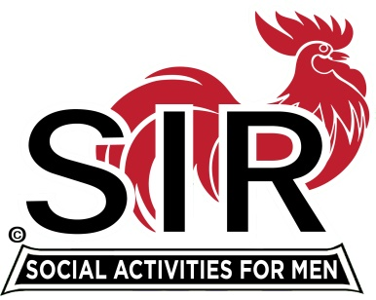

Activities ~ Friendship

Kirk McVean
On November 15th, 1999
You were inducted into Branch 116.
Art Donaldson was your sponsor.
Congratulations!
SIR Medallion1
Jerry Hicks
Jerry Hicks, Big Sir

